Automation Invigilation duties Screenshots

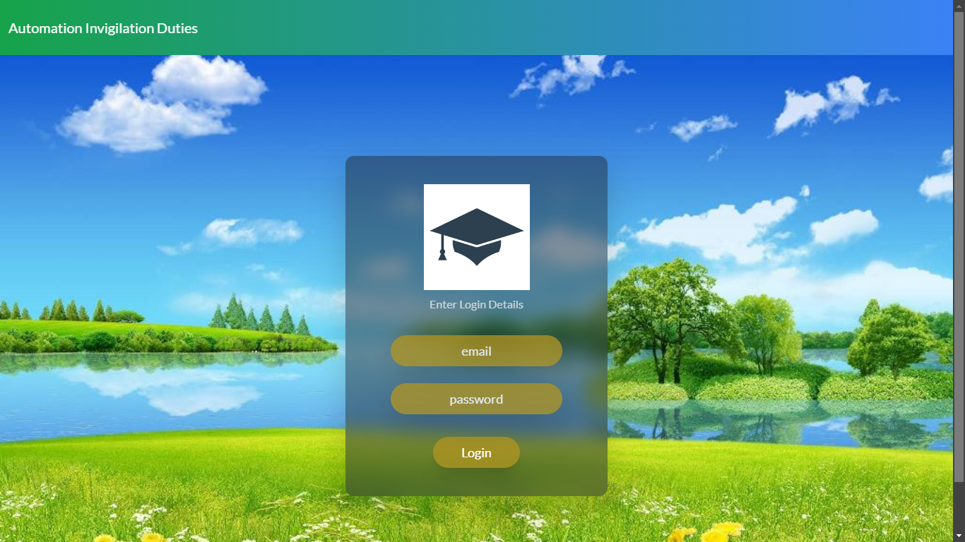

**Home page**: This is an our project home page. Here login is for hod, admin and faculty.

Here the Admin will login through email and password to enter in admin home page. Similarly

Hod and Faculty



**Admin Home page**: This is the Admin home page.

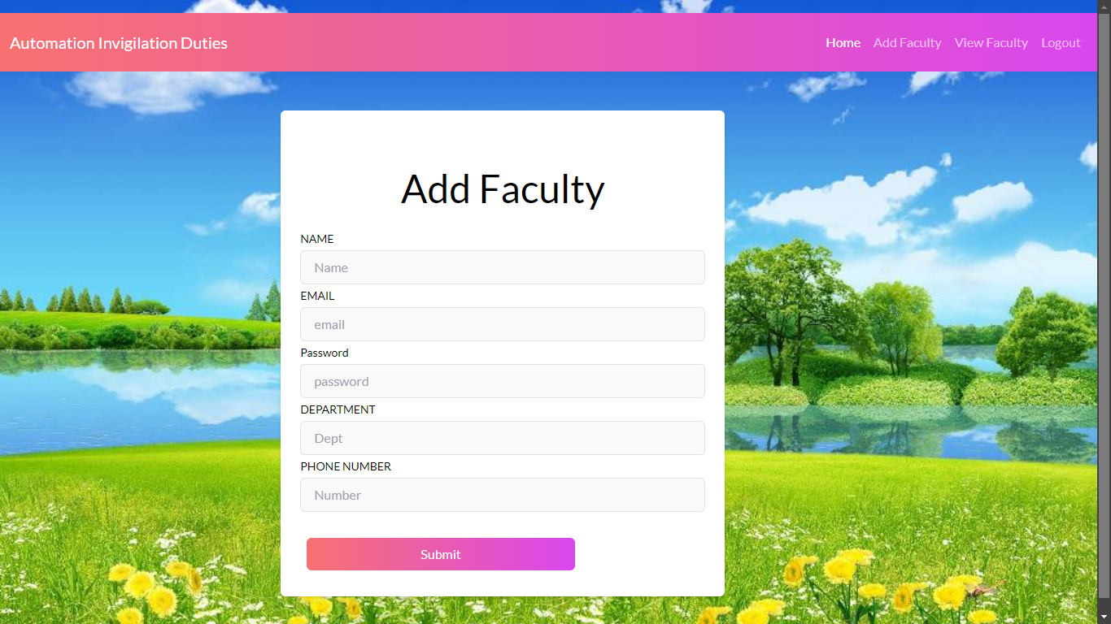

**Add Faculty**: After the Admin login he can add faculty.

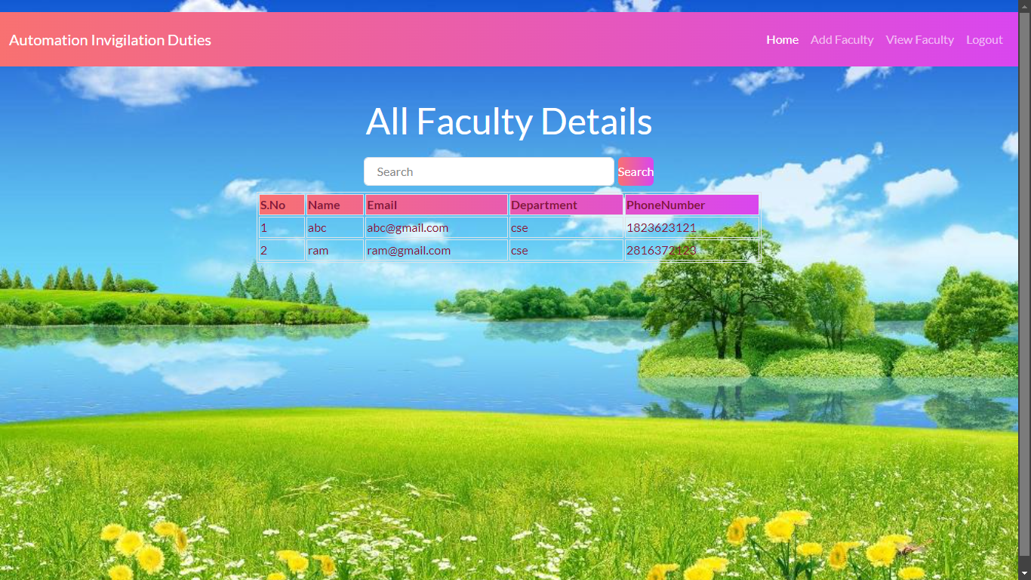

**View Faculty**: After adding faculty details he can view who are added.



**Exam Coordinator Home page**: This is the exam coordinator home page.

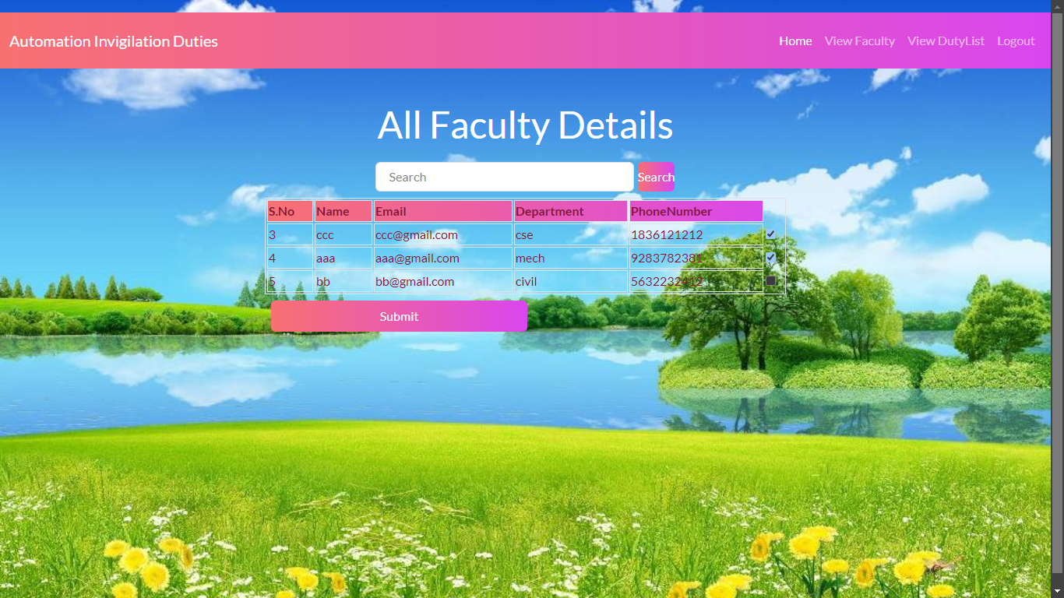

**View Faculty**: After adding faculty details by admin . Coordinator can view the faculty and can assign invigilation duties.

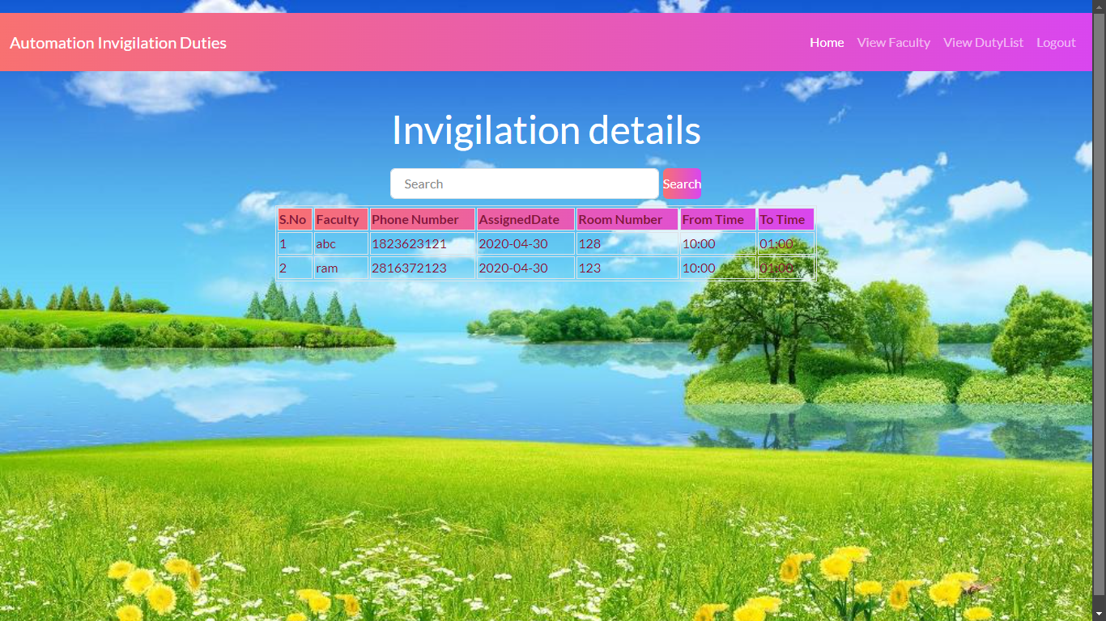

**View Duty List**: After assigning invigilation duties for faculty .he can view that time table .



**Faculty Home :**  Faculty home page

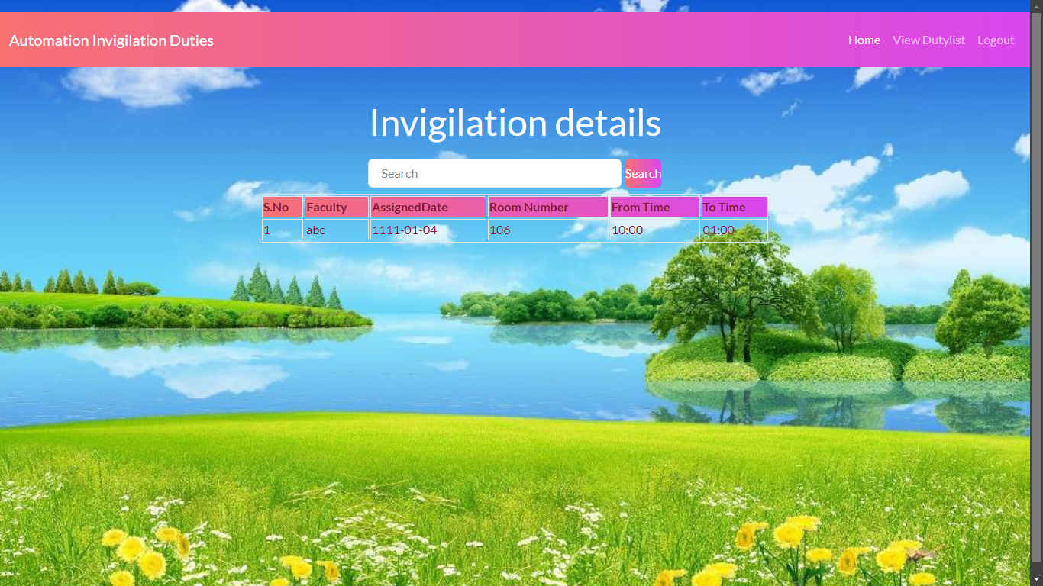

**View invigilation :** he can view assigned dutylist.